MACH4METAL

metalworking machinery
Transito 21,
6909 DA BABBERICH, Netherlands
Tel. + 31 (0)316 – 247123
Fax. + 31 (0)316 - 247956

Bank No : 66.52.13.883
IBAN : NL33 INGB 0665 2138 83
BIC : INGBNL2A
info@mach4metal.com www.mach4metal.com www.mach4metal.com

TOS CELAKOVICE SUA 100 Variant

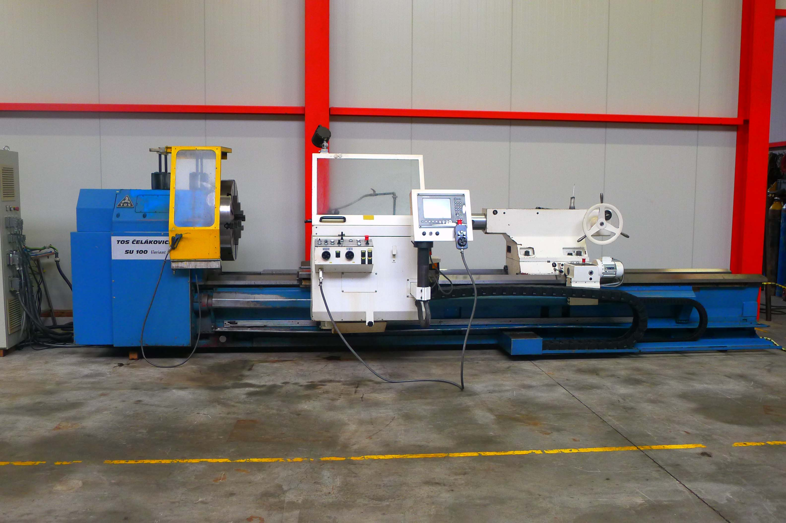
- Make : TOS Celakovice
- Typ : SUA 100 CNC Variant
- Age : 11/2001
- Mach.No. : 12 543

- Max. turning Ø bed : 1.050
- Max. turning Ø carriage : 730
- Centre height : 525
- Centre distance : 4.000
=
- Bed width : 800
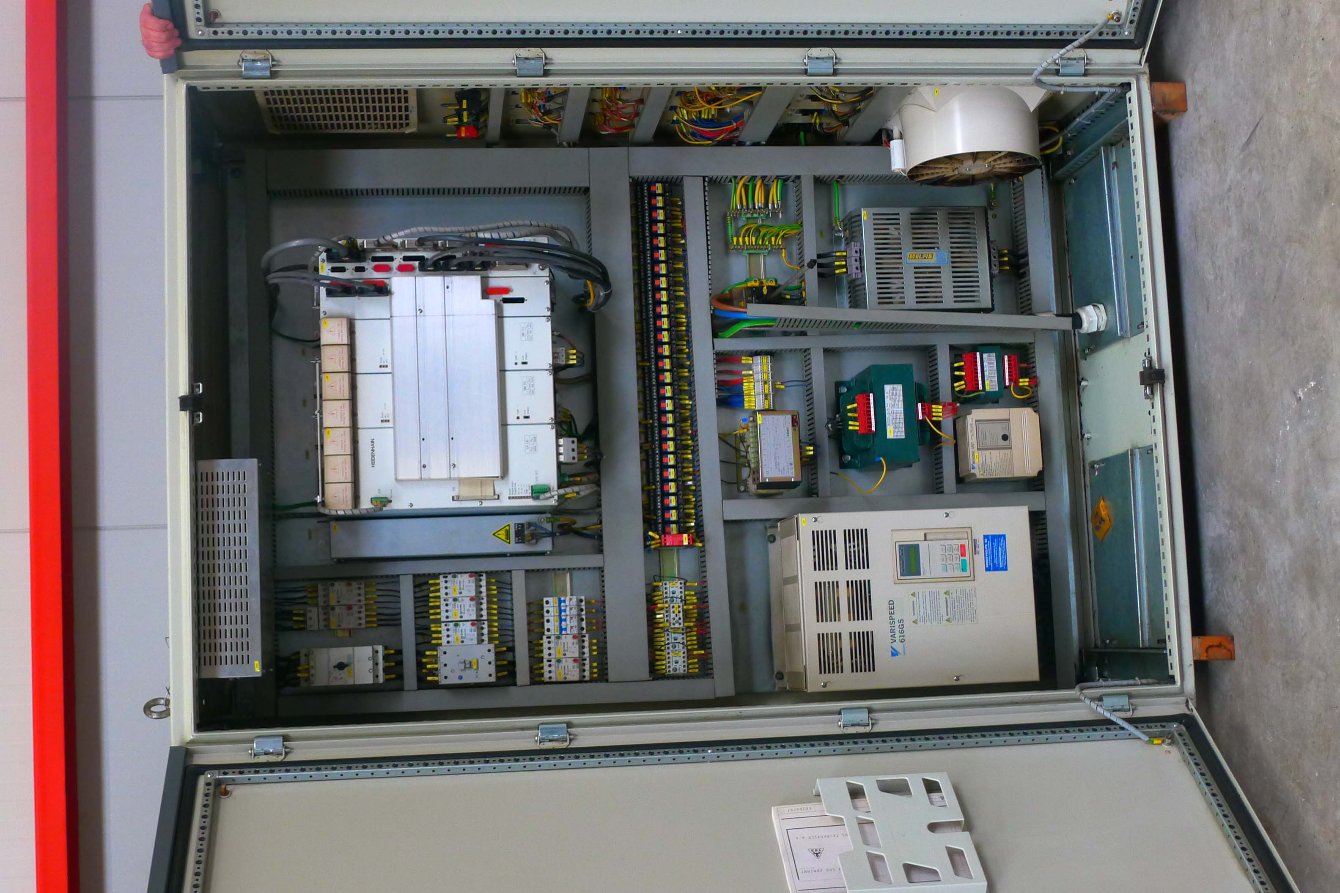
- Bed height : 630

- Spindle bore : 115
- Speeds 4 ranges : 6 – 560

- Pinole Ø : 150
- Stroke pinole : 200
- Work load Kg : 8.000 supported

- Dimensions:
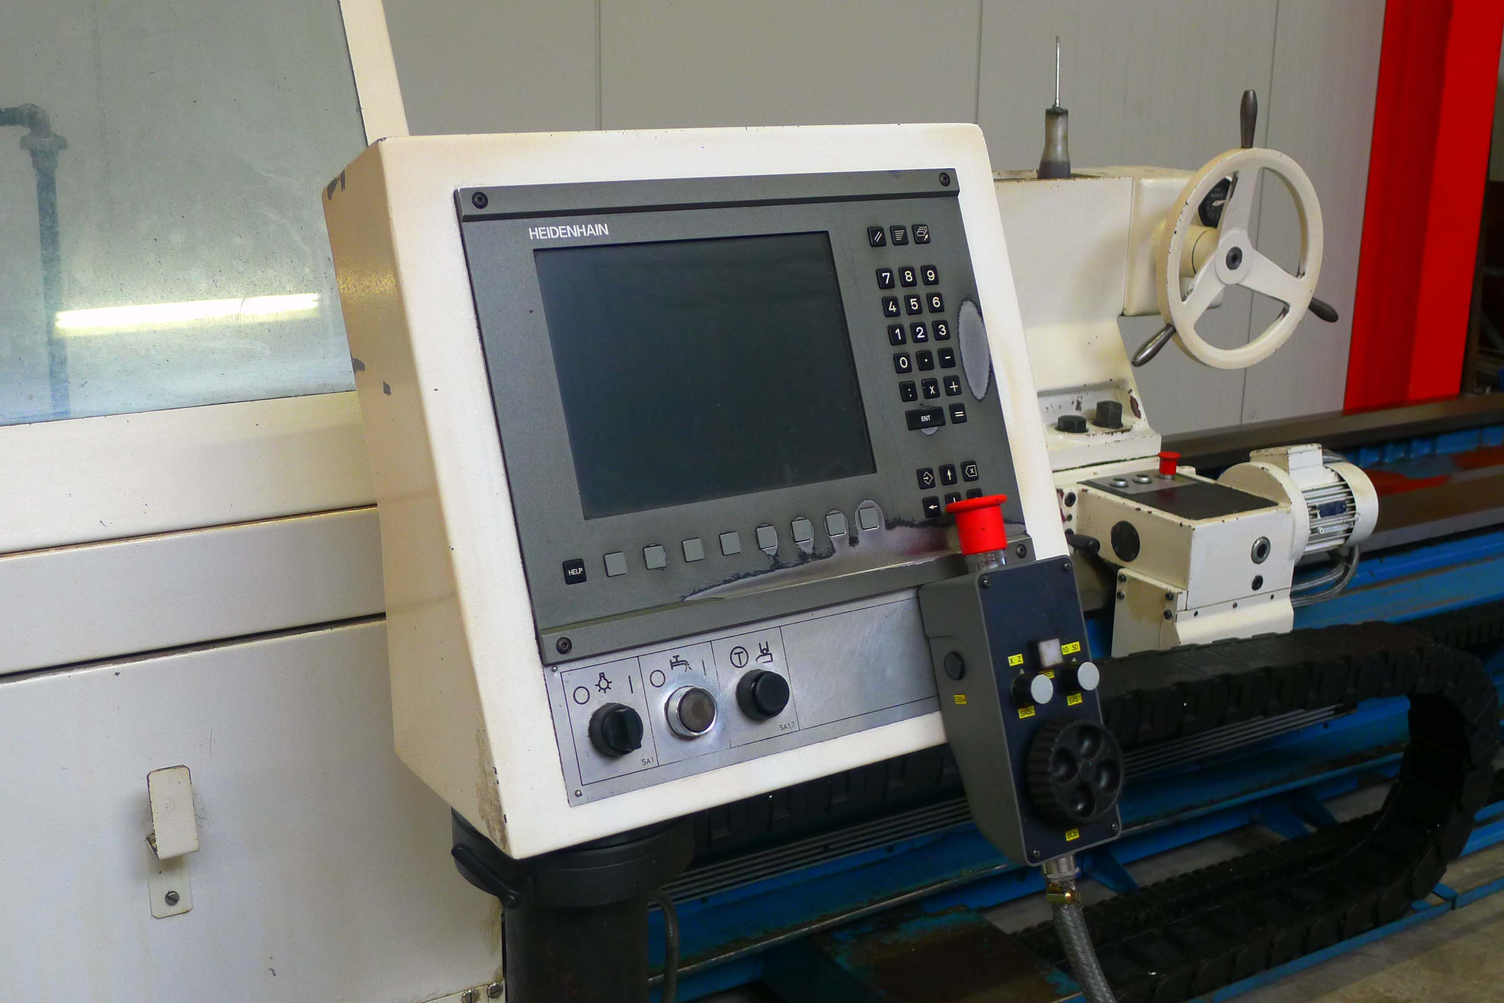
- Length : 6.860
- Width : 2.850
- Height : 1.830
- Weight : 9.400 Kg

- HeidenHain MANUEL PLUS V360
- Motorised tailstock
- CE safety guides / covers
- 4 chuck Ø 800 mm
- 2 x steady rest Ø
- Power feed on top slide

Please Note: The above information has been obtained to the best of our ability and belief from, and from the manufacturers where possible. It is given in good faith, but its accuracy can not be guaranteed. Accordingly, it will not form a representation or constitute contractual terms. We advise you to check any vital details!

